1. Write a Python program to implement Euclidean Algorithm to compute the greatest common divisor (gcd).

Expected Output :

304 = 2 * 150 + 4

150 = 37 * 4 + 2

4 = 2 * 2 + 0

gcd is 2

6 = 2 * 3 + 0

gcd is 3

1. **Consider the scenario of processing marks of students for a course in student management system . Given below is the list of marks scored by students. Find top three scorers for the course and also display average marks scored by all the students.**

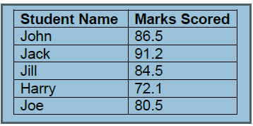

3. **Harley was booking flight tickets for the vacation trip. The ticket rates mentioned were as follows for the round-trip:**

**Rate per Child : 1/3rd of the rate per adult**

**Service Tax: 7% of the ticket amount (including all passengers)**

**As it was a holiday season, the airline also offered 10% discount on the final ticket cost (after inclusion of the service tax).**

**Harley booked the tickets for 2 adults and 3 children. Find and display the total ticket cost of Harley.**

**Test the program with different input values for number of adults and children.**